# Pl/SQL EXCERCISES

**Exercise 1: Control Structures**

**Scenario 1:** The bank needs to process monthly interest for all savings accounts.

* + **Question:** Write a stored procedure **ProcessMonthlyInterest** that calculates and updates the balance of all savings accounts by applying an interest rate of 1% to the current balance.

**Step1: Create required tables**

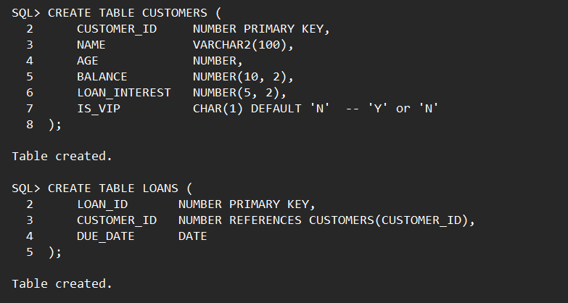

**Step2: Insert data into tables**

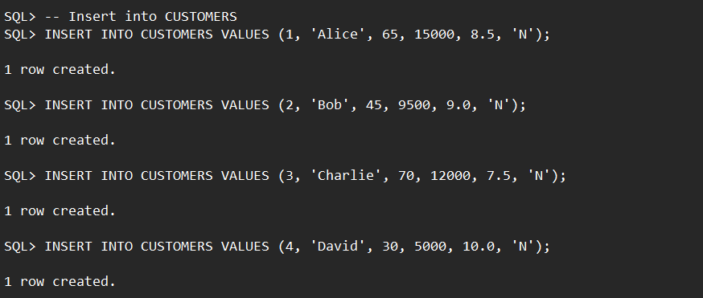

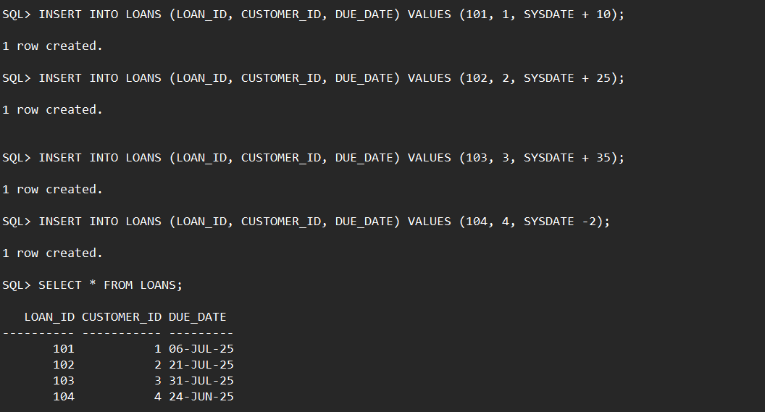

**Step3: Scenario 1 – Apply 1% Discount for Age > 60:**

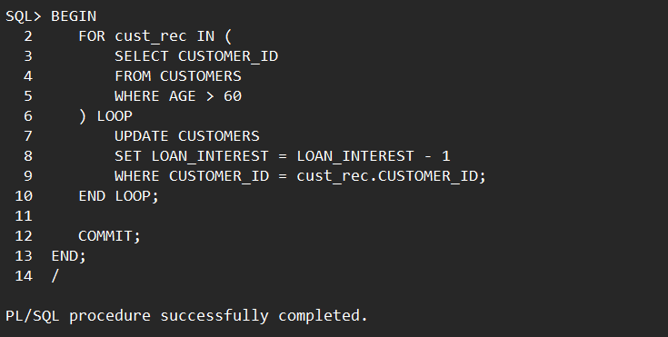

**Step-4 : Scenario 2 – Promote to VIP for Balance > $10,000**

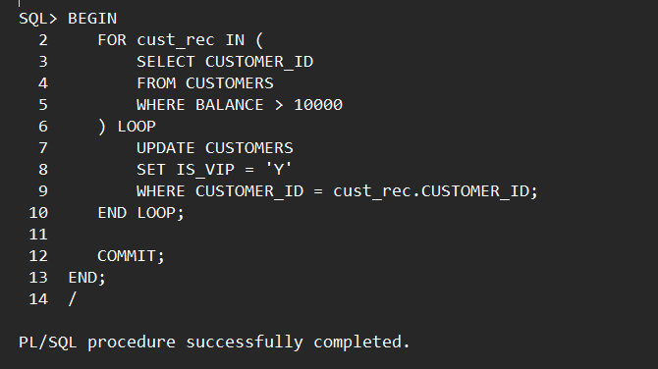

**Step-5: Scenario 3 – Loan Due Reminder (Next 30 Days)**

**Question: Write a PL/SQL block that fetches all loans due in the next 30 days and prints a reminder message for each customer**

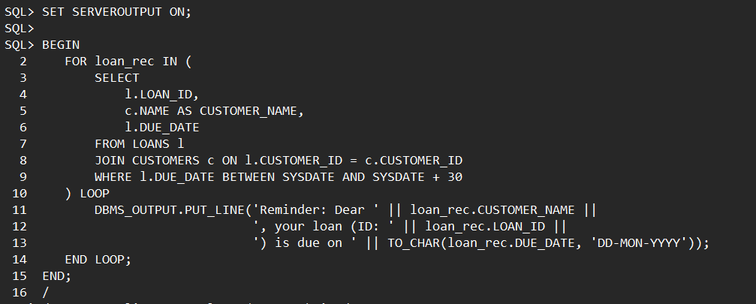

**Output:**

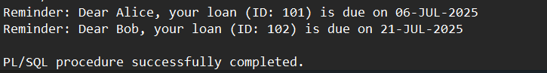

**Exercise 3: Stored Procedures**

**Scenario 1: The bank needs to process monthly interest for all savings accounts.**

* + **Question: Write a stored procedure ProcessMonthlyInterest that calculates and updates the balance of all savings accounts by applying an interest rate of 1% to the current balance.**

**Step 1:Create accounts table and insert data**

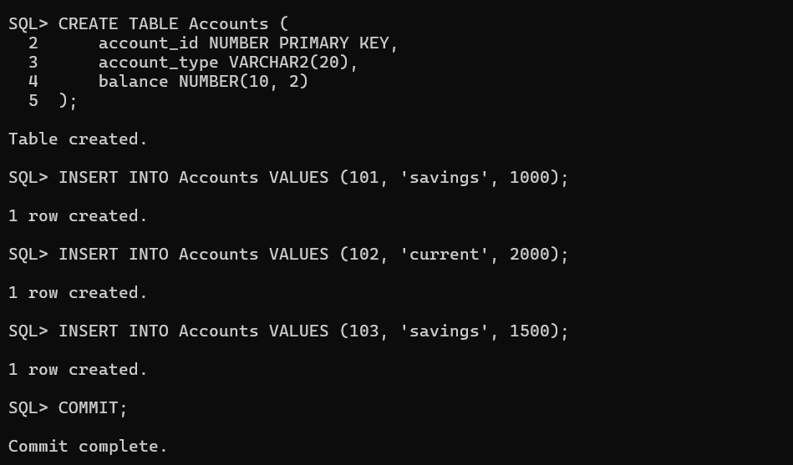

**Step 2: A stored procedure to calculate monthly interest**

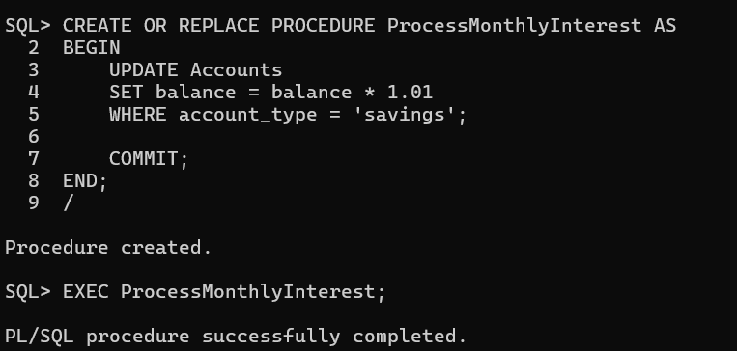

**Scenario 2: The bank wants to implement a bonus scheme for employees based on their performance.**

* + **Question: Write a stored procedure UpdateEmployeeBonus that updates the salary of employees in a given department by adding a bonus percentage passed as a parameter.**

**Step 1: Create employeees table**

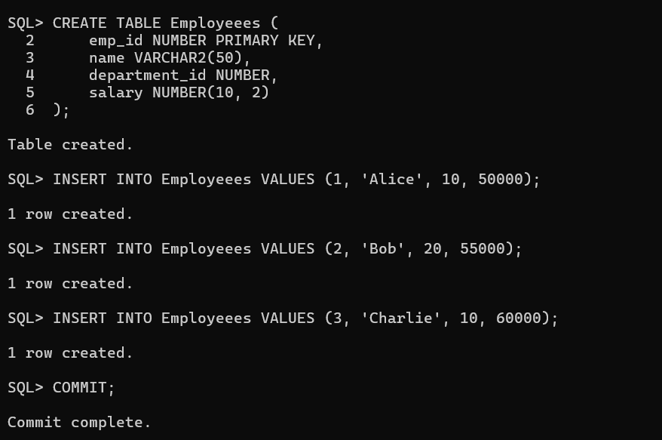

**Step 2: A Stored procedure to update the salary of employees in a given department**

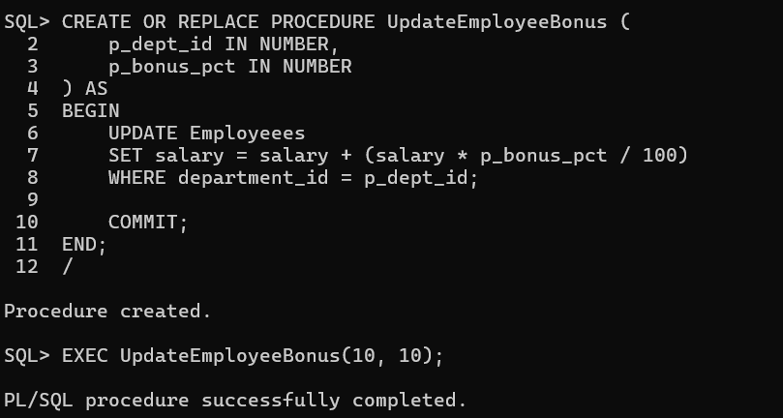

**Scenario 3: Customers should be able to transfer funds between their accounts.**

* + **Question: Write a stored procedure TransferFunds that transfers a specified amount from one account to another, checking that the source account has sufficient balance before making the transfer.**

**Step 1:Used the same accounts table and created a procedure to transfer funds between accounts**

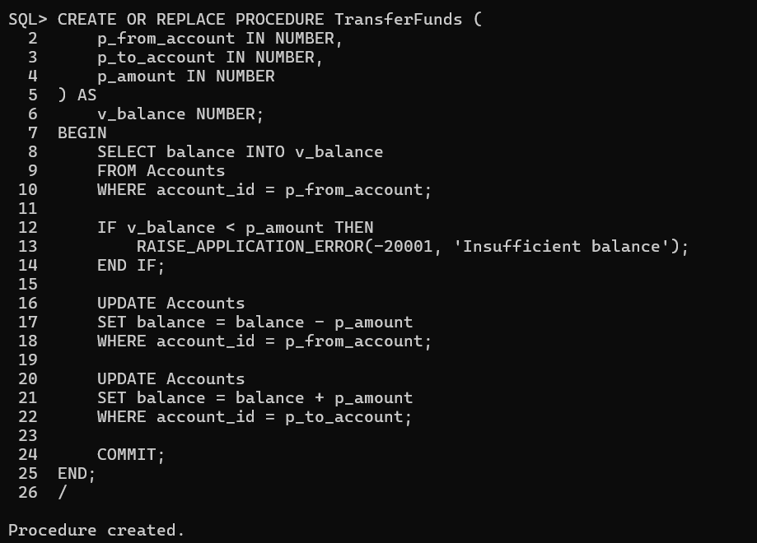

**Step 2:Transfering funds from one account to another**

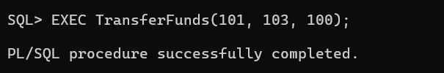

**Step 3: Results Before Transferring**

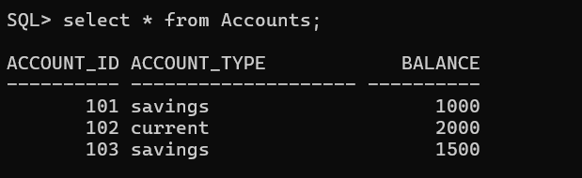

**After Transfer**

